**Project 2.7 planning**

Request response planning – commands:

DIR:

Request: DIR <directory path>

Response:

<directory path>:

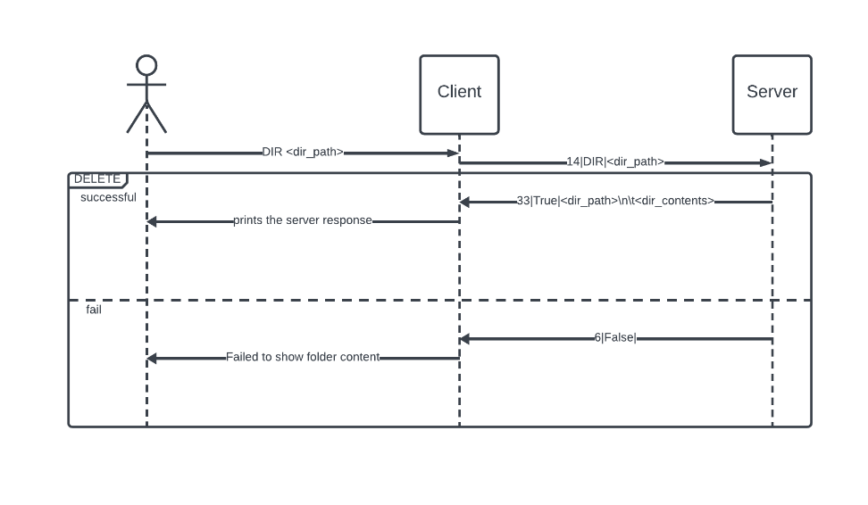Folder contents

DELETE:

Request: DELETE <file path>

Response: Deleted - <file path>

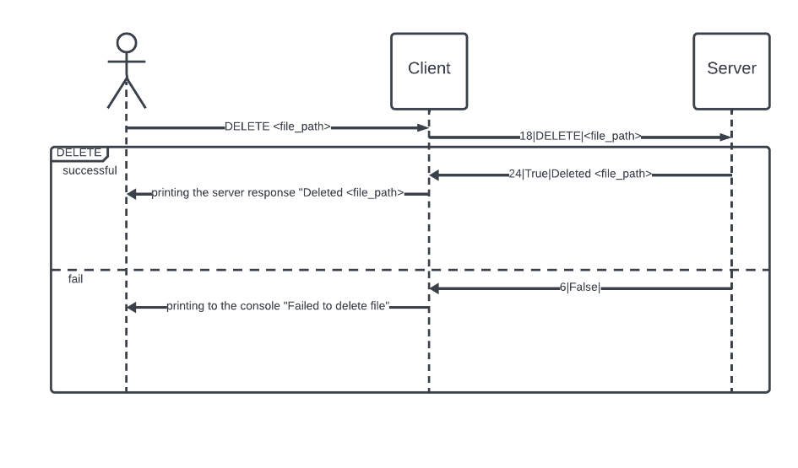

COPY:

Request: COPY <file to copy path> <file to copy to path>

Response: Copied <name of file to copy> to <name of file copied to>

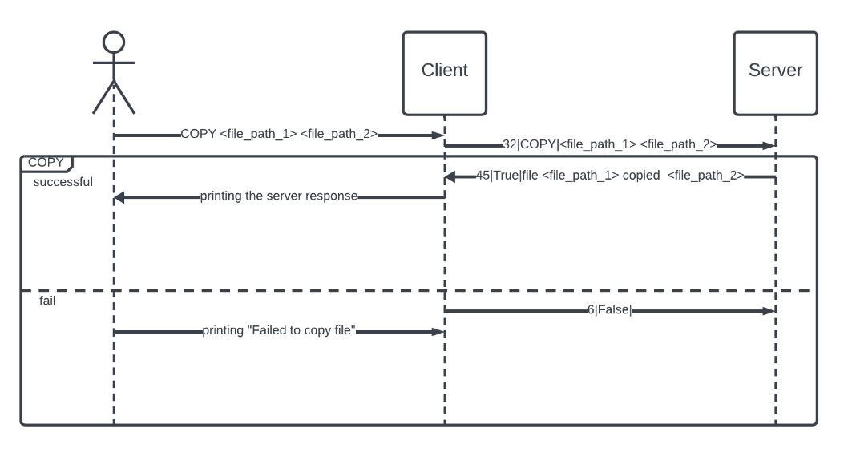

EXECUTE:

Request: EXECUTE <software>.exe

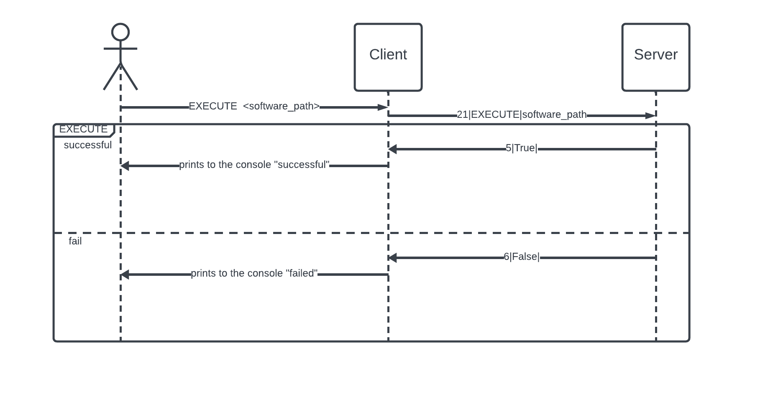Response: <software>.exe is running

SCREENSHOT:

Request: SCREENSHOT

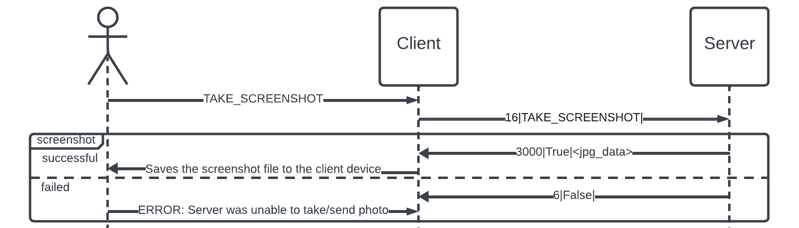Response: screenshot located in <screenshot path>

EXIT:

Request: EXIT

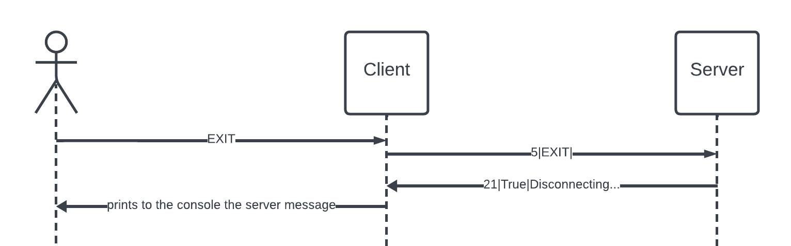Response: Disconnected

**Protocol planning**

Protocol from client to server:

Format: len_of_msg|command\was_successful|payload

Explanation:

Len_of_msg:

the length of the entire protocol formatted message so the server will know what to expect. Not including the length itself and separator.

In raw data.

Command: client -> server:

The command from the client

The command cannot contain the “|” character.

was_successful: server -> client:

tells if the command execution was successful.

This parameter will be typed as a Boolean.

payload:

the server return message – error/return message/arguments.

Transmitted in raw data.